
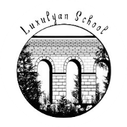
.
Luxulyan School
Uniform Guide

Adopted: May 2026 | Review date: May 2028

General Uniform

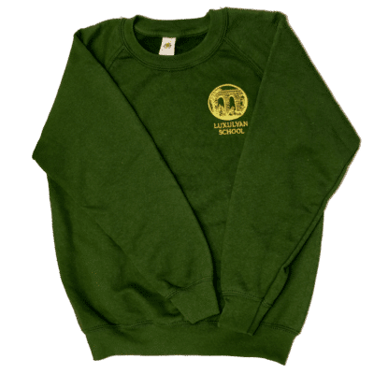  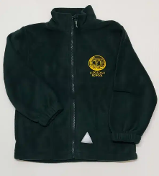 | Jumper / Cardigan  Bottle green jumper, fleece or cardigan with school logo. Available from screenprint (St Austell), Back British Farming or schooltrends.  A plain bottle green alternative from any retailer is equally acceptable. |  | 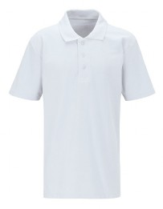 | Polo Shirt / Shirt  Plain white polo shirt (no logo required). Available from any retailer or supermarket.

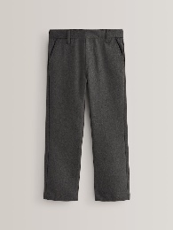  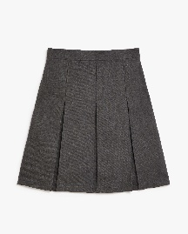 | Trousers / Skirt / Pinafore  Grey tailored trousers, shorts, skirts or pinafore dress. Skirts must be knee length or longer. No jeans, leggings or tracksuit-style trousers. |  | 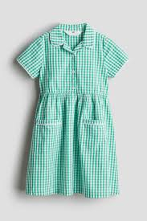  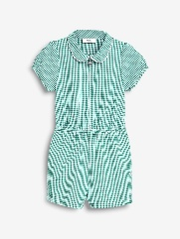 | Summer Dress  Green gingham dress or playsuit — summer term only. No logo required – available from any retailer or supermarket.

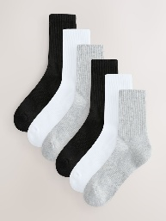 | Socks / Tights  Plain black, white or grey socks, or grey or green tights. Plain white socks with summer dresses. |  | 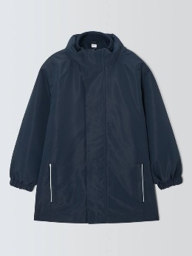 | Coat  Any suitable waterproof coat with hood. No branded requirement — any colour or retailer.

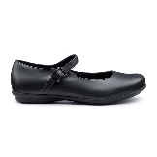  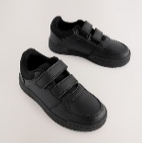 | Shoes  Plain black, leather or leather-look, formal style. No trainers, boots, heels or coloured trim.

PE Kit

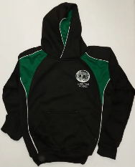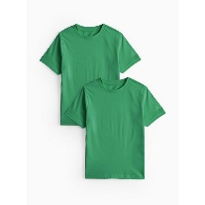 | PE Top  Plain green t-shirt  Optional PE hoodie with school logo |  | 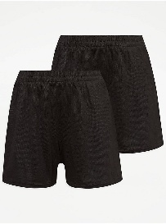 | PE Shorts / Bottoms  Plain black shorts or joggers/tracksuit bottoms in colder weather. No logo required.

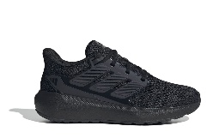  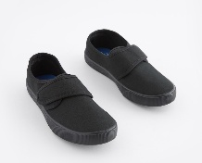 | Trainers  Safe, sturdy trainers of any colour or black velcro plimsolls. Any brand.

Hair, Jewellery and Appearance

 | Hair  Long hair (shoulder length or longer) must be tied back. Natural colour only. No extreme styles, tram lines, or very short grades. |  | 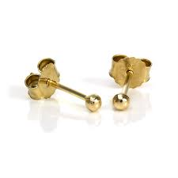 | Jewellery  One pair of plain small ear studs only. Studs must be removed for PE. No other jewellery. No smart watches.

Where to Buy

Non-branded items
All non-branded items can be purchased from any retailer, including supermarkets such as Asda, Tesco and Sainsbury's.
Branded / logoed items
Screenprint, 72 Stennack Road, St Austell PL25 3JQ 01726 68689
Back Bristish Farming
School Trends (online only) Luxulyan Primary School Uniform
Pre-loved / second-hand uniform
Pre-loved uniform is available from PALS (our PTA) at school events such as summer and Christmas fayres. Contact the school office to enquire about availability. If your child is in receipt of Pupil Premium and you need support with uniform costs, please contact us in confidence.

Please ensure all clothing is clearly labelled with your child's name.

