WHAT IS BIKEABILITY? Bikeability is the national cycle training programme supported and funded by the Department for Transport. The course builds the skills and confidence of children who can already ride. Bikeability cannot only make children better cyclists; potentially for the rest of their lives but can help with general confidence and independent thinking. All of our Bikeability training is delivered by qualified, professional, DBS checked National Standard Instructors. Visit www.bikeability.org.uk for more information

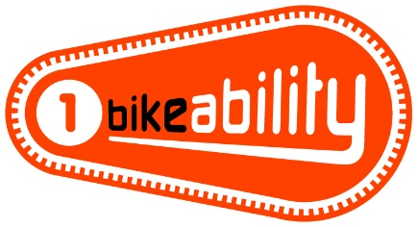 | The Bikeability Level 1 course helps children get more skilled and confident in riding their bikes in the playground and get them ready for cycling on the road. Riders must be able to ride a bike - pedal and freewheel- to participate in this level.
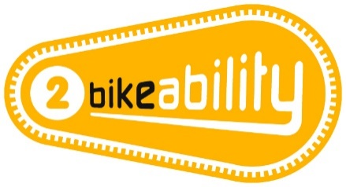 | The Bikeability Level 2 course aims to improve riders’ skills and confidence for cycling on smaller roads and simple junctions without too much traffic. It prepares riders for cycling on larger and busier roads and more complicated junctions. All the riders will have to show the instructors they can do everything at Bikeability Level 1 before they can go on the roads.
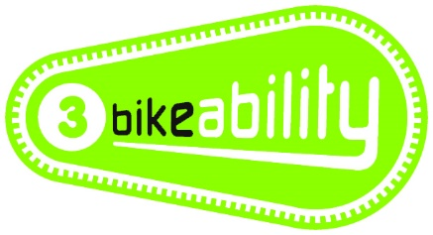 | The Bikeability Level 3 course aims to develop riders’ skills and confidence so they can ride in some everyday road environments, including busy roads and complex junctions. Riders must have achieved everything at Bikeability Level 2 before moving onto the Bikeability Level 3 course.

WHAT WILL YOUR CHILD NEED?
- A completed consent form
- A roadworthy bike without stabilisers
(see checklist overleaf)
- A helmet if required
- Suitable clothing for the weather conditions

FURTHER INFORMATION FOR PARENTS This course develops the cycling skills and confidence of children who can already cycle. Please ask your school about Bikeability Balance and Bikeability Learn to Ride if your child can’t already cycle. To benefit from Bikeability, your child must attend every session and practise what they learn after training. Bikeability skills and confidence will be lost without regular cycling. Bikeability engenders enthusiasm while building skills and confidence to cycle more safely, more often. Please support and encourage your child to continue cycling after training CLICK HERE for video support.

HOW TO BOOK Bikeability places are limited and places will be booked on a first come basis. Please CLICK HERE or scan the QR to complete your consent form.



GET READY (Visit bikeability.org.uk/bikeability-training/get-ready/ for more information) Before your course it is really important to have a few things sorted including:

Your bike - make sure you check that your bike is in good working order, with the tyres inflated and the moving parts working well. If you need to take it to a bike shop before-hand, don’t leave it to the last minute!

Your helmet - your helmet should sit on top of your head comfortably, (not too tight or too loose), with the peak sitting about two fingers width from your eyebrows. The side adjusters should sit just below your ears forming a nice V on the side of your head, and the chin strap should allow for two fingers to fit between it and your chin.

Your clothing - wear whatever you would normally wear to school, but you must also be prepared for the weather. On cold or wet days, make sure that you have your coat and gloves, and an extra layer or two. With a change of clothes available, just in case. On warm sunny days make sure you have put on a good amount of sun cream at the start of the day and keep drinking water throughout the day. And a top tip – as you will be using a bit more energy than normal bring an extra snack, also making sure you’ve had a good breakfast before school.

PRE-COURSE BIKE SAFETY CHECK
Visit bikeability.org.uk/bikeability-training/get-ready/



